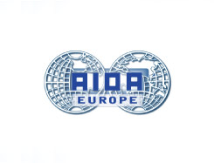

IV. AIDA Europe Conference / LONDON, 13/14 SEPTEMBER 2012

Session of AIDA Working Party − State Supervision on 13 SEPTEMBER 2012

Thursday, 13 Sept. 2012

Location: Grange Tower Bridge Hotel, 45 Prescot Street
London E1 8GP
Room: Bartholomew Suite

12.30 p.m. Introduction
- Dr Gunne W. Bähr, Germany
- Dr Ferenc Kiss, Hungary

12.45 p.m. Topic 1: EIOPA − Risks and Challenges for State Supervision in Europe − A discussion from the perspectives of different countries

Speakers re Topic 1: 1) Emma Greenow, DLA Piper UK LLP - Brussels' perspective.
2) Olivier Favre, Schellenberg Wittmer, Zurich - Switzerland's perspective.
3) Reinhard Dallmayr, BLD Bach Langheid Dallmayr, Munich -
Germany's perspective

13.30 p.m. Discussion

14.15 p.m. Topic 2: Presentation by student prize winner −
Angelo Borselli, Bocconi University

Speaker re Topic 2: "Keeping watch on giants: The supervision of insurance groups and of insurance undertakings within financial conglomerates in European law"

14.45 p.m. Discussion

15.00 p.m. Questionnaire, next meeting, topics for the next meetings etc.

For further information please contact Gunne Bähr at gunne.baehr@dlapiper.com.

